Student Lifestyle & Academic Productivity Analysis
IDHV Project - M2026
M. Pranav, K. Krish, Mayank Kumar

1. Introduction
The primary objective of this project is to analyze the relationship between student lifestyle—encompassing digital habits, study routines, and extracurricular engagements—and academic productivity. Productivity is evaluated based on Cumulative Grade Point Average (CGPA) and overall satisfaction with academic performance.
The core research question addressed in this study is: "How do student lifestyles affect their academic performance and productivity?"

1.1 Scope of Student Lifestyle Parameters
To comprehensively define student lifestyle, the following parameters were taken into consideration:
- Time spent in the gym or structured workouts.
- Average hours per week spent playing sports.
- Average hours of sleep per night on weekdays.
- Typical sleep timeframe on weekdays.
- Perceived sleep quality over the past month.
- Use of digital devices before going to sleep.
- Average daily screen time.
- Time spent on social media platforms (e.g., Instagram, YouTube Shorts, Facebook).
- Time spent on gaming or OTT media streaming (e.g., Netflix, Prime Video).
- Frequency of digital device distractions.
- Time dedicated to studying outside of class (including assignments and exam preparation).
- Consistency in maintaining study routines.
- Class attendance percentage.
- Stress levels over the preceding four-week period.
- Ability to maintain concentration while studying.
- Frequency of feeling mentally fatigued or drained.

2. Methodology

2.1 Statement of Objectives
The objective of this study is to analyze the relationship between students’ lifestyle habits and academic productivity. We focus on key parameters including physical activity, screen time, sleep patterns, study habits, stress, concentration, and academic performance.

2.2 Population, Sampling Frame, and Sampling Units
The target population consists of college students. The sampling frame comprises students accessible via the campus survey, and the sampling unit is defined as an individual student.

2.3 Sampling Design
We employed simple random sampling, ensuring that each student within the sampling frame had an equal probability of selection. Data regarding lifestyle and academic habits was gathered via an on-campus survey.

2.4 Questionnaire Design
The questionnaire was constructed using Google Forms and structured into sections addressing student background, physical activity, sleep, screen time, study habits, academic performance, and overall well-being.
The variables were categorized into three distinct groups:
- Dependent Variables: Academic productivity, concentration, stress, mental fatigue, and sleep quality.
- Independent Variables: Physical activity, sports participation, sleep duration, screen time, social media usage, study hours, and consistency of study routine.
- Potential Confounding Variables: Year of study, gender, class attendance, and additional lifestyle factors that may influence the target relationships.
A combination of question formats was utilized:
- Likert Scales: Five-point ratings measuring stress, concentration, productivity, sleep quality, and subjective experiences.
- Categorical Questions: Multiple-choice options for year of study, gender, workout frequency, sleep timing, and class attendance.
- Numerical Questions: Quantitative inputs for sleep duration, screen time, study hours, and SGPA/CGPA.
- Optional Responses: Options such as "Prefer not to say" to preserve respondent privacy.

2.5 Classification of Data
The collected dataset comprises both quantitative and qualitative information:
- Quantitative Data: Sleep duration, screen time, study hours, SGPA/CGPA, and numerical ratings.
- Qualitative Data: Gender, year of study, workout frequency categories, sleep timing, class attendance brackets, and perceived impacts of physical activity.
Note that the five-point rating scale responses yield ordinal data due to their inherent order.

2.6 Type of Dataset
This study utilizes cross-sectional data, captured from multiple respondents during a single survey interval.
Unlike time-series data, which monitor trends over time, cross-sectional data enable comparisons across individuals at a specific point in time. The study does not incorporate pooled cross-sectional or panel data structures.

2.7 Data Recording Method
Data was gathered using the self-report method via Google Forms, with participants providing information regarding their lifestyle habits, study routines, academic metrics, and well-being.
While this method effectively captures personal subjective experiences, self-reported metrics may be subject to recall bias or subjective estimation errors.

2.8 Organization of Fieldwork
The fieldwork workflow comprised objective formulation, target population definition, sampling unit determination, instrument design, data collection, and data structured preparation. The aggregated dataset will undergo data preprocessing, descriptive analysis, exploratory analysis, and visualization to assess the core relationships.

3. Data Preprocessing

3.1 Data Organization

The survey data was collected through Google Forms and organized into a structured dataset containing information on students' lifestyle habits, study routines, academic performance, and well-being. The variables included numerical data, categorical responses, and ordinal ratings. The dataset was organized so that each row represented a student and each column represented a variable, making it easier to perform statistical analysis.
3.2 Data Preprocessing
The raw dataset was checked for inconsistent formats, missing values, duplicate records, and invalid numerical entries. Column names and response formats were standardized, and numerical variables such as sleep hours, study hours, screen time, and CGPA were converted into numeric formats. Categorical responses were checked for consistency, including capitalization, extra spaces, and similar response labels. Numerical values were also checked against reasonable limits, such as 0–24 hours for daily activities and 0–10 for CGPA. The data was then prepared for further analysis while preserving the original meaning of the responses.
3.3 Missing Data Analysis
We examined missing values at both the variable and respondent levels to understand the extent and pattern of missingness. Sleep hours had the highest missingness at 30.19%, followed by study hours at 28.30%. The three screen-time variables had 22.64% missing values each, while CGPA had 18.87%. The missingness plot showed that missing values were concentrated in certain variables and respondents, with some screen-time variables missing together.
We also explored whether missingness was associated with factors such as year of study and gender. This helped us assess the possible missingness mechanisms: MCAR (Missing Completely at Random), MAR (Missing at Random), and MNAR (Missing Not at Random). For example, students may have chosen not to disclose their CGPA. However, these observations were treated as possible explanations rather than conclusive proof of any particular missingness mechanism.
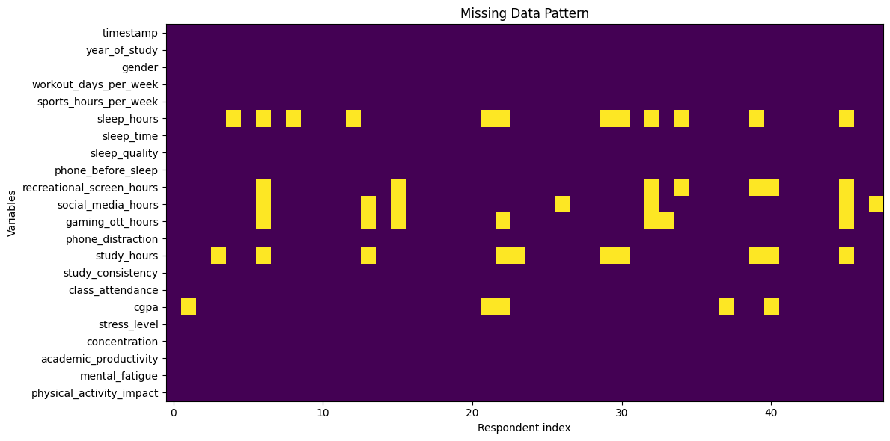

3.4 Imputation and Handling
Four completely empty responses and one highly incomplete response with at least 10 missing values were removed, leaving 48 respondents. We then used different imputation methods based on the type of variable:
- Median imputation: Missing numerical values, including sleep hours, study hours, screen time, and sports hours, were replaced with their respective medians. The median was chosen because it is less affected by extreme values than the mean and provides a reasonable central value for these variables.
- Rounded median imputation: Missing ordinal ratings, such as sleep quality, stress, concentration, and academic productivity, were filled using the rounded median. This preserved the original rating scale and avoided introducing fractional ratings.
- Mode imputation: Missing categorical values, such as gender, year of study, sleep timing, and physical activity impact, were filled using the most frequent category. This maintained valid responses within each category.
- CGPA handling: Missing CGPA values were not imputed. Since some students may have chosen not to disclose their grades, filling them with an estimated value could introduce bias and misrepresent their actual academic performance. These values were retained as missing and excluded from analyses requiring CGPA.

After preprocessing and imputation, the final dataset contained 48 respondents and 21 variables, with no duplicate rows or invalid numerical values. Six CGPA values remained missing and were excluded from analyses requiring CGPA. The cleaned dataset was saved separately and used for subsequent statistical analysis.

